Test Summary for Lab 7

(Shruti Ratna Charugulla)

Purpose 1

Overview of SideeX 1

Tests Executed 2

Automation Testing – Record and Playback 2

Metrics 3

Test Cases 3

Defects 3

Test Environment and Tools 4

Exit Criteria 4

Conclusion/Sign off 4

## Purpose

This report provides a summary of the testing conducted to verify the proper page load for multiple pages loaded by verifying the title of each web page that gets loaded.

## Overview of SideeX

SideeX is an open source record-playback-style web application testing tool. It is an extended version of Selenium IDE with a number of expanded automation capabilities. It runs as an extension in both Chrome and Firefox browsers. Below is a snapshot of the SideeX’ graphical user interface.

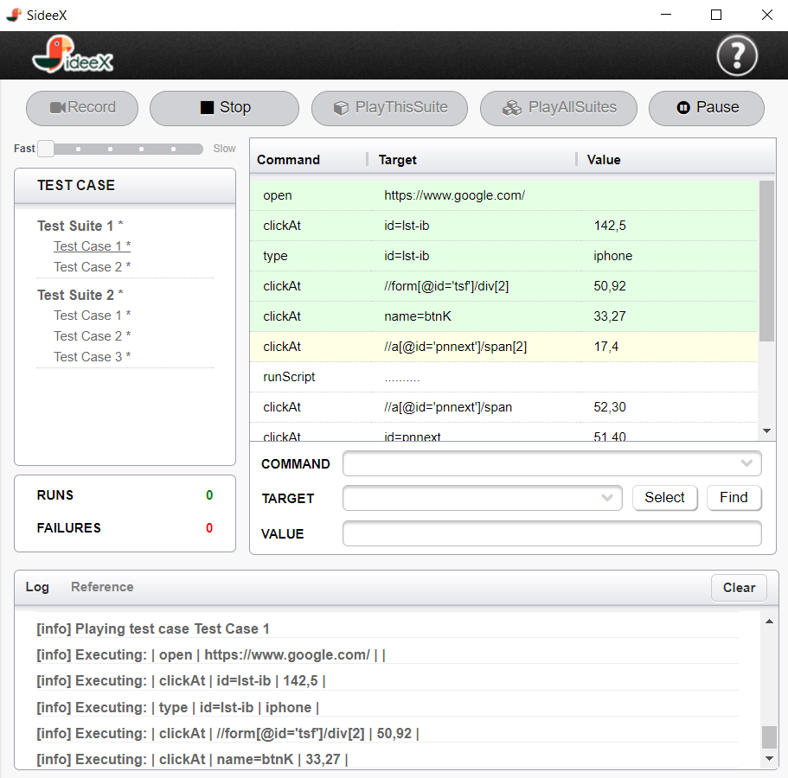

## Tests Executed

### Automation Testing – Record and Playback

The test cases listed below was recorded using the record feature in SideeX application:

#### Test Case 1:

1. Navigate to the webpage <https://www.abileneisd.org/abilenehs>.
2. Navigate to the SideeX command line and left click on the X, then scroll down.
3. Left click on “verify title”, and in the “Value” field type “Abilene High School”.

#### Test Case 2:

1. Click on the 1st Tab, “Administration”.
2. Navigate to the SideeX command line and left click on the X, then scroll down.
3. Left click on “verify title”, and in the “Value” field type “Principal—Mr. Michael Garcia”.

#### Test Case 3:

1. Click on the 2nd Tab, “Support Staff”.
2. Navigate to the SideeX command line and left click on the X, then scroll down.
3. Left click on “verify title”, and in the “Value” field type “Counselors”.

#### Test Case 4:

1. Click on the 3rd Tab, “Faculty/Staff”.
2. Navigate to the SideeX command line and left click on the X, then scroll down.
3. Left click on “verify title”, and in the “Value” field type “Faculty/Staff Directory”.

#### Test Case 5:

1. Click on the 4th Tab, “Athletics”.
2. Navigate to the SideeX command line and left click on the X, then scroll down.
3. Left click on “verify title”, and in the “Value” field type “Athletics Directory”.

#### Test Case 6:

1. Click on the 5th Tab, “Departments”.
2. Navigate to the SideeX command line and left click on the X, then scroll down.
3. Left click on “verify title”, and in the “Value” field type “Fine Arts”.

#### Test Case 7:

1. Click on the 6th Tab, “Grade Levels”.
2. Navigate to the SideeX command line and left click on the X, then scroll down.
3. Left click on “verify title”, and in the “Value” field type “Freshmen”.

#### Test Case 8:

1. Click on the 7th Tab, “Organizations”.
2. Navigate to the SideeX command line and left click on the X, then scroll down.
3. Left click on “verify title”, and in the “Value” field type “Flashlight”.

#### Test Case 9:

1. Click on the 8th Tab, “Parents”.
2. Navigate to the SideeX command line and left click on the X, then scroll down.
3. Left click on “verify title”, and in the “Value” field type “Booster Clubs”.

#### Test Case 10:

1. Click on the 9th Tab, “Alumni”.
2. Navigate to the SideeX command line and left click on the X, then scroll down.
3. Left click on “verify title”, and in the “Value” field type “AHS Alumni”.

The test cases were saved into a Test suite with the name –“Lab 7 – Shruti Charugulla” and then the test suite was played back to verify if the test cases were executed successfully.

## Metrics

### Test Cases

|  |  |  |  |
| --- | --- | --- | --- |
| Test Cases Planned | Test Cases Executed | TCs Passed | TCs Failed |
| 10 | 10 | 10 | 0 |

### Defects

None

## Test Environment and Tools

Below is a table that includes a brief overview of the software and hardware setups used to execute the test cases described in this report.

|  |  |
| --- | --- |
| Automation testing tool | SideeX |
| Computer hardware | 2.3 GHz Intel Core i5, 4GB RAM |
| OS | OS X El Capitan Version 10.11.1 |

## Exit Criteria

* The planned test cases need to be passed.
* No critical defects found.
* The recorded test suite successfully played back.

## Conclusion/Sign off

All exit criteria were met and satisfied.